Integrated cell therapy process development: The importance of post-manufacturing storage and delivery
JANUARY 6, 2014
Here at Akron, we are big proponents of integrated cell therapy process management – from pre-development planning through to post-manufacturing logistics.
Challenges to the development of marketable cell-based therapies line the entire development process. Optimization of the cryopreservation and transport of stem cell products is a key element to that equation. The shipping method is critical in order to preserve the integrity and viability of the tissues and final cell products when being transported from the manufacturing site to the customer or medical facility. Which is why successful cell therapy business models account for the impact of cryopreservation and shipping of end products. When it comes to cryopreservation, for instance, strategies to improve the process have included lowering the DMSO content to reduce potential toxicity, improving on potential contamination and infection from human or animal viruses stemming from serum products and using environmentally friendly cryopreservation agents in order to reduce the overall cost of the process.
A reduction in cost of materials and potential licensing opportunities become critical when optimizing strategies for the delivery of new cell-based therapy products.
FDA guidelines and standards become even more important for storage and transport of GMP products, where traceability, record keeping and access are critical (Harel A., Cell & Tissue Transplantation & Therapy 2013:5 1–7). Similarly, there are numerous strategies for shipping. For instance, cells can be shipped frozen at -20C or -80C, the choice of which depends on the specific process but must ensure high post-thaw viability. Included below is an image (reproduced from Harel, A. 2013) illustrating the entire cell banking process for autologous mesenchymal stem cell therapy, from acquisition of the raw cell material through to shipping of the end products in approved shipping containers.
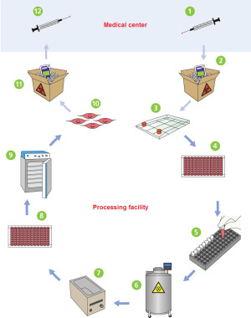
The industry has been recognizing the importance of integrated cell therapy models, wherein post-production is equally as important as the development stages. The 10th Phacilitate Cell & Gene Therapy Forum, to be held in Washington, DC this coming January, 27th-29th, will dedicate its plenary session to the road to commercialization of cell therapy products, with a special emphasis on GMP storage and global distribution strategies of cell-based therapy products. With the standardization of guidelines for cell therapy product transport, such sessions will become even more critical.
In recent months, Akron has been focusing on improving its line of industry-leading cryopreservation solutions. From the introduction of DMSO-free cryosolutions based on poly-L-lysine to its proven lineup of CryoSolve products, we believe that one size doesn’t fit all, and that future trends will bring a need for solutions tailored to specific cell therapy products.

